EXPERIENTIAL ENGINEERING EDUCATION FABRICATION / MODEL DEVELOPMENT

REPORT ON

# SMART WALKING STCK

*A Report submitted*

***By***

**NAVEEN DUNNA - 20951A1250**

IARE-New-Logo_Black.png

Name of the Department

# INSTITUTE OF AERONAUTICAL ENGINEERING

**(Autonomous)**

**Dundigal, Hyderabad – 500 043, Telangana**

**June, 2022**

**EXPERIENTIAL ENGINEERING EDUCATION FABRICATION / MODEL DEVELOPMENT**

**Title of your Idea : SMART WALKING STICK**

**Thrust Area / Sector : ARTIFICIAL INTELLIGENCE / IOT**

**Branch & Section : INFORMATION TECHNOLOGY & A**

**Year / Semester : 3nd YEAR / 5th SEMESTER**

| **S. No** | **Name of the Student** | **Roll Number** | **Mobile Number** |
| --- | --- | --- | --- |
| **1.** | Naveen Dunna | 20951A1250 | +91 8096761110 |
|  |  |  |  |

**1. Abstract of your Idea:**

* Blind person finds it difficult to detect the presence of any obstacles in their way while moving from one place to another and it is very difficult to find the exact location of the stick if it have been misplaced.
* Thus, the smart stick comes as a proposed solution to help the visually impaired people in their day to day living without the help of others. In this paper we proposed a solution for the blind people by using an ultrasonic sensor in the blind stick. The instrument stands used to perceive the obstacles at the range of four meters and infrared instrument is castoff to perceive the nearer complications in front of the blind people.
* Thus, the radio frequency transmitter and receiver help the user to find the exact location of the smart stick with the help of buzzer. The vibration motor which is placed in the smart stick gets activated and produces a vibration when any obstacle is detected.
* This proposed method uses the Arduino UNO as controller. The branch is accomplished of sensing all difficulties in front of the user. The smart stick is of user friendly, quick response, very low power consumption, lighter weight and it is easy to hold and fold by the user.

**2. Objectives & Significance:**

* The main objective is to provide voicebased assistance to blind people. In this technology controlled world, where people strive to live independently, this project proposes an ultrasonic stick for blind people to help them gain personal independence. Since this is economical and not bulky, one can make use of it easily.
* The main advantage of the system is that it helps the blind people in both indoor and outdoor, care-free navigation. The devices placed in the stick makes it comfortable and easy to handle.
* The smart stick helps in detecting obstacles placed at a distance in front of the user. The system is suitable for both indoor and outdoor environment. The information regarding obstacles is given through voice alerts, eliminates the difficulty of understanding vibration patterns which was used in earlier systems.
* The system is a moderate budget mobile navigational aid for the visually impaired.

**3.Background of the Idea:**

* The main purpose of this walking stick is to provide safety for the blind people. A smart walking stick is a type of protective hand gear used by the blind people a smart walking stick aims to reduce fire accidents by using the fire sensors smart walking stick boosts the safety levels.
* Smart Walking Stick helps blind people in moving and allowing them to perform their work easily and comfortably.
* In normal cane or stick, the detection of the obstacle is done by using the sensor. But it is not efficient in the case of visually impaired persons.

1. **Detailed Problem Description:**

* Smart walking stick is specially designed to detect obstacles which may help the blind to navigate care-free. The audio messages will keep the user alert and considerably reduce accidents.
* A voice enabled automatic switching is also incorporated to help them in private space as well. This system presents a concept to provide a smart electronic aid for blind people, both in public and private space.
* The proposed system contains the ultrasonic sensor, water sensor, voice play back board, raspberry pi and speaker. The proposed system detects the obstacle images which are present in outdoor and indoor with the help of a camera.
* The Stick measures the distance between the objects and smart walking stick by using an ultrasonic sensor. When any objects or obstacles come in range of an ultrasonic sensor then the head phone tell the name of obstacle which is in front of the stick.

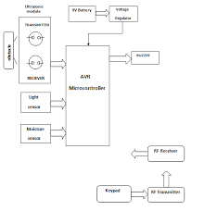

* The smart walking stick is a simple and purely mechanical device to detect the obstacles on the ground. This device is light in weight and portable. But its range is limited due to its own size.
* It provides the best travel aid for the person. The blind person can move from one place to another independently without the others help.
* The main aim of the system is to provide an efficient navigation aid for the blind persons which gives a sense of vision by providing the information about their surroundings and objects around them.

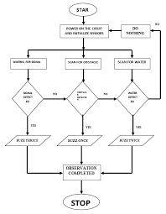

1. **Proposed Innovative Solution and Methodology:**

The proposed system has been divided into two parts. The first part was about designing the smart stick using SOLID WORK software. SOLID WORK is modelling software that allows the user to design product in 2 and 3 dimensions in simple and almost cost-free methods. The design using SOILD WORK software has been done into two phases. The first phase was designing every part alone. Then, the second phase was to assemble the parts together.

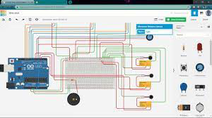

**SOLID WORK SOFTWARE**

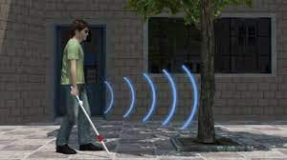

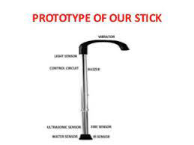

* The stick contains three ultrasonic sensors positioned in front, right and left position.
* The actuators are the vibrating motor and the buzzer to alarm the person from any flame that will be detected by the sensor.
* The electronic system has been controlled using Arduino UNO. When the switch on the top of the stick; the Ultrasonic is immediately sending the signal from the transmitter.
* However, when the signal impacts the level surface it reflects back to the sensor`s receiver. Therefore, the Arduino will send a pulse to the actuators (in this case, the vibrating motor and the buzzer) to work as the uploaded code.

**6.Design and Modeling (Software or Hardware) of the proposed solution:**

* Our technology model helps in the detection of flame or obstacles around the blind people and gives a signal in order to prevent the situation.
* This is the best way to protect the blind people through the fire accident and their injuries due to the fire.
* So, this technology enhances the productivity of smart walking sticks and increase in technology basis for the safety of blind people.

According to the problem when certain fire is identified from the environment then data value is greater than the expected value then using the python script for Arduino, we send a signal through the transmitter.

**INFRARED**  **DETECTOR:**

* Infrared detectors have been available for many years, however, it has only been in recent times that technology has allowed for stable, accurate detection to occur. There are two types of Infrared detectors, single frequency and multi spectrum.
* The detector is sensitive to a narrow band of radiation around the 4.4 micron range which is a predominant emission band for hydrocarbon fueled fires. Additionally, the sun’s radiation at this band is absorbed by the earth’s atmosphere, making the IR flame detector solar blind.
* Single frequency detectors use a pyroelectric sensor, which responds to changes in IR radiation intensity. In addition they incorporate a low frequency band pass filter, which limits their response to those frequencies that are characteristic of a flickering fire. In response to a fire signal from the sensor, electronic circuitry in the detector generates an output signal.

**STRENGTHS OF THE SINGLE FREQUENCY IR DETECTOR**:

* Highly immune to optical contaminants like oil, dirt, and dust.
* High speed response under 30 milliseconds for some brands.
* Insensitive to solar, welding, lightning, X-rays, sparks, arcs and corona.

**LIMITATIONS OF THE SINGLE FREQUENCY IR DETECTOR:**

* Generally not suitable for non-carbon fires
* Some brands will respond to modulated infra-red sources
* Rain, ice and water vapour on the detector lens will inhibit detection

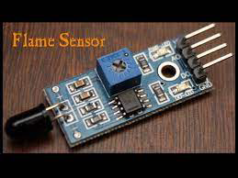

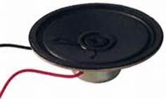

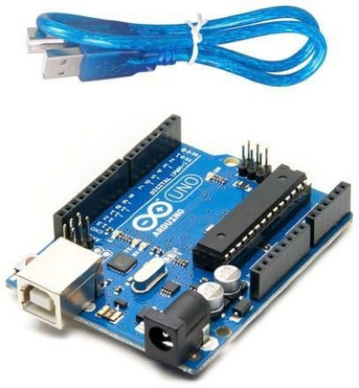**ARDUINO UNO BOARD**

* **ARDUINO UNO**

∙ Arduino UNO

A microcontroller chip is based on Atmega328p microchip. It's an open-source board. The board has 14 digital pins, 6 analogue pins and can be powered by USB cable or 9v external battery.

* **BUZZER**

A "piezo buzzer" is basically a small speaker which will be connected directly to an Arduino. "Piezoelectricity" is an impression where certain crystals can deform once electricity is applied to them. By applying an electrical signal at the proper frequency, the crystal will create a sound.

* **FLAME DETECTING SENSOR**

It can detect infrared light with a wavelength ranging from 700nm to 1000nm. The far-infrared flame probe converts the light detected in the form of infrared light into current change.

**7. Detailed description of the Prototype or Product(Including block diagrams, working principles, explanation of each and every components, Technology description and demonstration):**

WHAT DO I CONNECT A FLAME DETECTOR TO?

Flame detectors can be connected in 4 different ways to provide varying degrees of information.

1.**Stand Alone**– The detector is fitted with internal relays that provide alarmand fault outputs. When the detector senses a fire it activates warning devices and some method of fire suppression. This is the simplest method of connection and while the detector does have LED status there is not any remote indication in the event of a fire or if the detector fails.

**2.Fire Alarm Panel** – the detector is connected to a Fire Alarm Panel (FAP) as part of an overall site detection system. Warning devices and suppression systems can be operated, the advantages are that the power supply to the detector is monitored, and indication of the detector status is centralised.

**3.Control Panel** – the detector is connected to a dedicated flame detector control panel, this is used when the site does not have a Fire Alarm Panel. This system offers the same advantages as a FAP.

**4.Monitoring System**– the detector provides a 4-20mA output that connects to a site monitoring system. The output provides multiple alarm and fault conditions. The advantage of this system is that the flame detectors can be incorporated into a system that is monitoring other functions on the site such as air conditioning.

FLAME DETECTOR INSTALLATION

As with all fire detectors the placement of flame detectors is determined by the environment that they will be operating in. What appears to be a good place to locate a flame detector on paper may be a poor location in reality. Some of the factors to consider are;

* The viewing angle of the detector
* The detection range
* Obstructions such as girders, beams, supports, hoists, air conditioners and other solid objects will block the cone of vision and / or hinder access for service
* All high risk fire ignition areas must be covered by at least one detector
* Adequate detector coverage will ensure that ‘voids’ in the optical coverage do not occur
* Optimum detector mounting height is a function of the height of the most likely point of fire ignition.

When designing a system we recommend that a manufacturer be contacted as details can be provided on previous installations of a similar nature. This will ensure that the correct number of detectors is provided to ensure the most suitable detection.

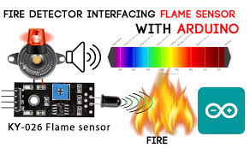

**CODE FOR FLAME SENSOR**

// lowest and highest sensor readings:

const int sensorMin = 0; // sensor minimum

const int sensorMax = 1024; // sensor maximum

void setup() {

// initialize serial communication @ 9600 baud:

Serial.begin(9600);

}

void loop() {

// read the sensor on analog A0:

int sensorReading = analogRead(A0);

// map the sensor range (four options):

// ex: 'long int map(long int, long int, long int, long int, long int)'

int range = map(sensorReading, sensorMin, sensorMax, 0, 3);

// range value:

switch (range) {

case 0: // A fire closer than 1.5 feet away.

Serial.println("\*\* Close Fire \*\*");

break;

case 1: // A fire between 1-3 feet away.

Serial.println("\*\* Distant Fire \*\*");

break;

case 2: // No fire detected.

Serial.println("No Fire");

break;

}

delay(1); // delay between reads

}

**8. Details of the deployment of product:**

Demand for such type of sensors is very high in the market and most importantly it is very important to blind people .

* This system gives the result for all 270 degrees from the position of the smart walking stick. So this system provides overall support for the blind society in guiding. The broad beam angle ultrasonic sensors help in wide range obstacle detection. The main aim of this system is to act as a secure guard and help the blind to be aware of their surroundings and fire .
* Where the Stick acts as a basic platform for the coming generation of more aiding devices to help the visually impaired to navigate safely both indoor and outdoor. It is effective and affordable. It leads to good results in detecting the obstacles on the path of the user in a range of three meters and also fire . This system offers a low-cost, reliable, portable, low power consumption and robust solution for navigation with obvious short response time. Though the system is hard-wired with sensors and other components, it's light in weight.

**9.Outcomes & Scope for the future extension:**

* Our technology model helps in the detection of fire around the blind people and gives you a signal in order to prevent further fire accidents.
* This is the best way to protect blind people by themselves and can avoid injuries due to that .
* So, this technology enhances the protection of blind people and increase in technology basis for the safety of visually impaired people.

**10.REFERENCES:**

**YouTube link:** [**https://www.youtube.com/watch?v=KpKoWD5\_hZU**](https://www.youtube.com/watch?v=KpKoWD5_hZU)

**Website link: 1.** [**https://instrumentationtools.com/flame-detectors-working-principle/**](https://instrumentationtools.com/flame-detectors-working-principle/)

**2.**[**https://create.arduino.cc/projecthub/SURYATEJA/arduino-modules- flame-sensor-6322fb**](https://create.arduino.cc/projecthub/SURYATEJA/arduino-modules-%20%20%20%20flame-sensor-6322fb)

**3.** [**https://www.enggjournals.com/ijet/docs/IJET17-09-05-302.pdf**](https://www.enggjournals.com/ijet/docs/IJET17-09-05-302.pdf)

**4.**[**https://www.researchgate.net/publication/342399208\_Smart\_Blind\_Stick**](https://www.researchgate.net/publication/342399208_Smart_Blind_Stick)